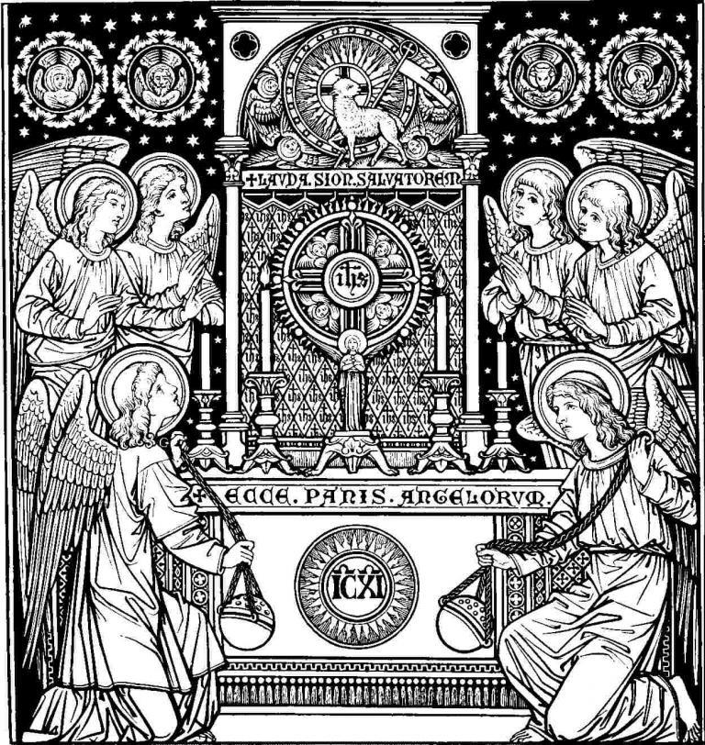

PRAYER FOR A SPIRITUAL COMMUNION
My Jesus, I believe that You are present
in this Holy Sacrament of the altar.
I love You above all things
and I passionately desire
to receive You into my soul.
Since I cannot now receive You sacramentally,
come spiritually into my soul
so that I may unite myself wholly to You
now and forever. Amen.
based on a prayer of St Alphonsus Liguori

